Experiment 5: Missionaries and Cannibals Problem:

Aim
To solve the Missionaries and Cannibals problem using an Artificial Intelligence search algorithm to find a safe sequence of boat crossings that transports all missionaries and cannibals from the left bank to the right bank without ever letting cannibals outnumber missionaries on either bank.

Objective
- To understand state-space search and constraint-based problem solving.
- To solve the Missionaries and Cannibals problem using AI techniques.
- To find a safe sequence of moves from the initial state to the goal state.

Algorithm
- Read the initial state: 3 Missionaries and 3 Cannibals on the left bank, boat on the left bank.
- Read the goal state: 3 Missionaries and 3 Cannibals on the right bank, boat on the right bank.
- Generate all possible boat moves (1 or 2 people, any combination of missionaries and cannibals).
- Compute the resulting state of both banks for each move.
- Check whether the resulting state is safe (cannibals do not outnumber missionaries on either bank, unless missionaries are zero).
- If the state is safe and not already visited, mark it visited and add it to the queue.
- Repeat steps 3 to 6 until the goal state is reached.
- Display the sequence of moves (solution path) from the initial state to the goal state.
- Stop.

Flowchart
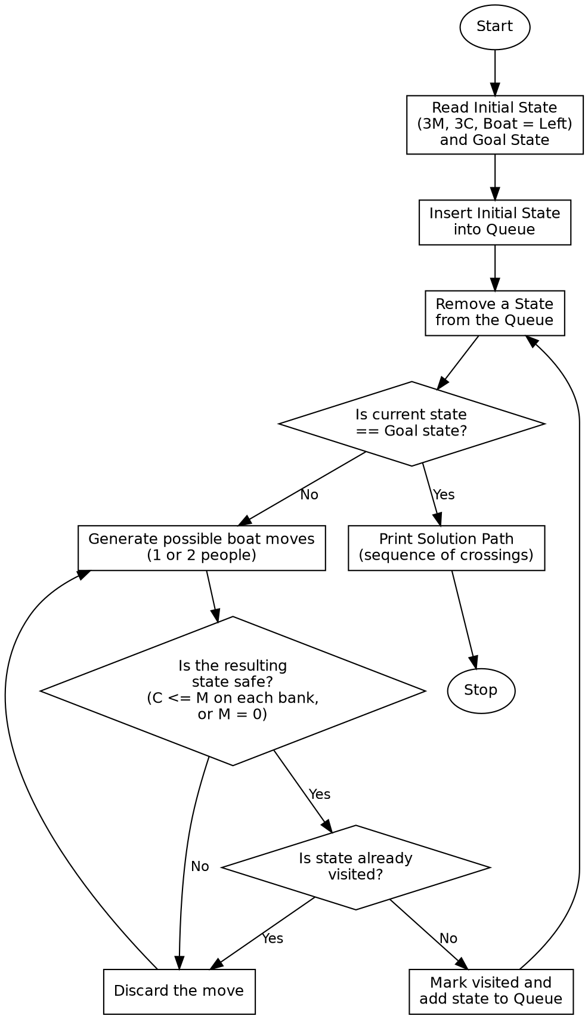

Program:

from collections import deque
M_TOTAL = 3
C_TOTAL = 3
start = (3, 3, 1) # (missionaries_left, cannibals_left, boat_side: 1=left, 0=right)
goal = (0, 0, 0)
moves = [(1, 0), (2, 0), (0, 1), (0, 2), (1, 1)]
def is_valid(m, c):
if m < 0 or c < 0 or m > M_TOTAL or c > C_TOTAL:
return False
if m > 0 and m < c:
return False
m_right, c_right = M_TOTAL - m, C_TOTAL - c
if m_right > 0 and m_right < c_right:
return False
return True
def bfs(start, goal):
queue = deque([(start, [start])])
visited = {start}
while queue:
state, path = queue.popleft()
if state == goal:
return path
m, c, boat = state
for dm, dc in moves:
if boat == 1:
new_state = (m - dm, c - dc, 0)
else:
new_state = (m + dm, c + dc, 1)
nm, nc, nb = new_state
if is_valid(nm, nc) and new_state not in visited:
visited.add(new_state)
queue.append((new_state, path + [new_state]))
return None
def describe(state):
m, c, boat = state
side = "Left" if boat == 1 else "Right"
return f"Left Bank -> M={m} C={c}, Right Bank -> M={M_TOTAL-m} C={C_TOTAL-c}, Boat on {side}"
if __name__ == "__main__":
print("Initial State: 3 Missionaries, 3 Cannibals, Boat on Left Bank")
print("Goal State : 0 Missionaries, 0 Cannibals, Boat on Right Bank\n")
solution = bfs(start, goal)
if solution:
print(f"Solution found in {len(solution) - 1} moves!\n")
for step, state in enumerate(solution):
print(f"Step {step}: {describe(state)}")
else:
print("No solution exists.")

Sample Input
Missionaries (M) = 3, Cannibals (C) = 3, Boat Capacity = 2
Initial Position: Left Bank Goal Position: Right Bank

Sample Output
Initial State: 3 Missionaries, 3 Cannibals, Boat on Left Bank
Goal State : 0 Missionaries, 0 Cannibals, Boat on Right Bank
Solution found in 11 moves!
Step 0: Left Bank -> M=3 C=3, Right Bank -> M=0 C=0, Boat on Left
Step 1: Left Bank -> M=3 C=1, Right Bank -> M=0 C=2, Boat on Right
Step 2: Left Bank -> M=3 C=2, Right Bank -> M=0 C=1, Boat on Left
Step 3: Left Bank -> M=3 C=0, Right Bank -> M=0 C=3, Boat on Right
Step 4: Left Bank -> M=3 C=1, Right Bank -> M=0 C=2, Boat on Left
Step 5: Left Bank -> M=1 C=1, Right Bank -> M=2 C=2, Boat on Right
Step 6: Left Bank -> M=2 C=2, Right Bank -> M=1 C=1, Boat on Left
Step 7: Left Bank -> M=0 C=2, Right Bank -> M=3 C=1, Boat on Right
Step 8: Left Bank -> M=0 C=3, Right Bank -> M=3 C=0, Boat on Left
Step 9: Left Bank -> M=0 C=1, Right Bank -> M=3 C=2, Boat on Right
Step 10: Left Bank -> M=1 C=1, Right Bank -> M=2 C=2, Boat on Left
Step 11: Left Bank -> M=0 C=0, Right Bank -> M=3 C=3, Boat on Right

Result
The given Missionaries and Cannibals problem was successfully solved and a safe solution path was obtained.

Conclusion
The Missionaries and Cannibals problem demonstrates constraint-based state-space search in Artificial Intelligence and shows how search algorithms find a safe solution while satisfying the given safety constraints.

